Hardil Vora

An easy access app for phone and tablets, made available offline
Elite apps at a Glance
Project Overview

Project Overview
A quick and easy access app for services like maintenance, site tasks, housekeeping, safety tests, inspections, etc. which are specially used for mobile operations.
The project contains the following parts:
- Mobile/Web Apps (Power app) – for end user
- Dynamics CRM – for data storage, permission and records management
All the menu tiles, tabs, cards, etc. are viewed and managed based on RBAC (Role Based Access Control) from CRM.
The app has a special feature that it can work in Offline Mode, the user must connect to an internet connection at the start to fetch all the data. After this the app can work in offline mode.
Data regarding parks, plots, units and unit fields are brought in by them from Business Central.
Created By | Hardil Vora
Created On | 29th May, 2026

URLs
For testing we have Development (DEV) Environment while UAT Environment is used for testing from company’s side.
- DEV CRM (Model-driven App) URL: https://eliteappsdev.crm11.dynamics.com/
- DEV App (Canvas App) URL: https://make.powerapps.com/environments/be1a2f74-2acf-e258-9a07-22b5687c6fa9/apps
  - In power apps, go to Apps=>All=>EliteApps then Press “Play” button to launch the app.
- UAT CRM (Model-driven App) URL: https://development4-uat.crm11.dynamics.com/
- UAT App (Canvas App) URL: https://make.powerapps.com/environments/dec9410f-9c2f-e9c9-acc1-4049995a23ab/apps
  - In power apps, go to Apps=>All=>EliteApps then Press “Play” button to launch the app.
Note: PRD is not available to us, it is used by the company.

App Overview
The Home Page of the application displays –
- Hamburger Button – Right of the Header
- Menu Tiles – Main Display Screen or Home Page Modules
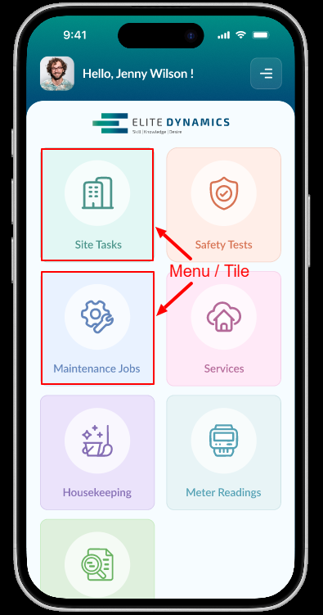
Mobile View

The Hamburger Button has four options –
- Dropdown menu options –
  - Home
  - Sync
  - Requests
  - Language
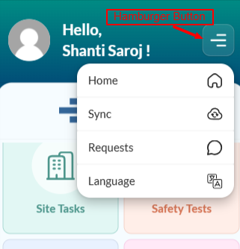
Hamburger Button
- Usage of each option:
  - Home – (It is a requirement from the company)
  - Sync – To sync the existing data between the mobile app with crm
  - Requests – Used to Show/Add all requests made by the end user
  - Languages – Used to Change the Language for the Mobile app
The application has seven menus/tiles namely –
- Site Tasks
- Safety Tests
- Maintenance Jobs
- Services
- Housekeeping
- Meter Readings
- Inspection
Inside each Menus there are few cards such as –
- To Do
- Next 7 Days
- Completed
- All
- High Priority
Note: “High Priority” card is shown only in the Maintenance Jobs Menu
It has a Toggle Switch between Mine(user) and Team which shows the record detail based on whichever is chosen. Teams are created in CRM. If you are the member of a Team, then the team tasks will be displayed to the user.
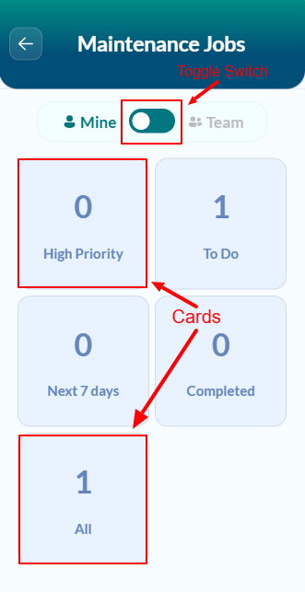
Cards & Toggle Switch

Inside each Card (E.g. Meter Reading), there are sections which display records regarding what, where, when, status, comments, etc. are shown. This page also has a search bar to search for records based on keywords. Along with that, two buttons at the top of the page namely – back button and sort option button.
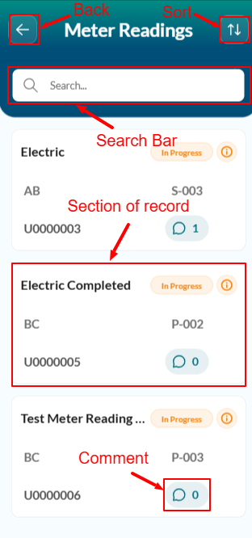
Task Display Page
- Section of Records – Displays task details like task description, task status, park code, plot no, unit no & comment
- Search Bar – To search based on keywords
- Sort – Sort based on a particular field
- Back – To return to the previous page
- Date – Shows Due Date of the task (Only visible for certain menus)

Section of records/tasks
The section of records/tasks displays data regarding a particular task
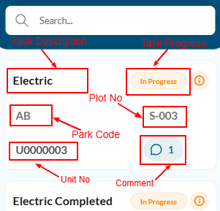
Record Description
By clicking on any of the sections of record, user can access detailed information about that task.
Detailed information
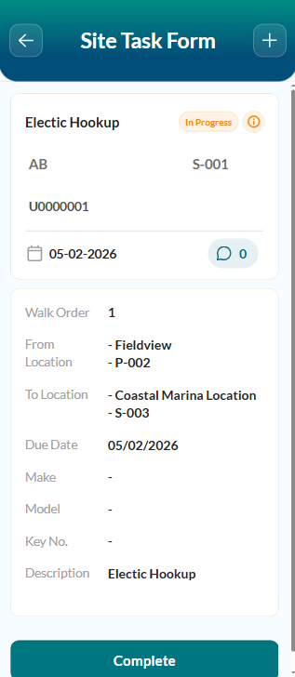
Task More Details
There is an “Add button” at the top-right corner of the screen where you can add “requests” and view “more information” regarding the task.
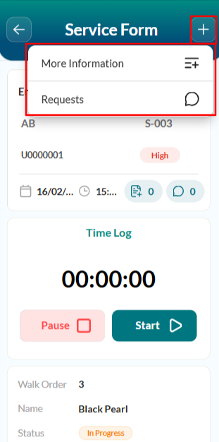
Add Info / Request

Sort Button
Sort Button has three options –
- Job No.
- Walk Order
- Plot Number
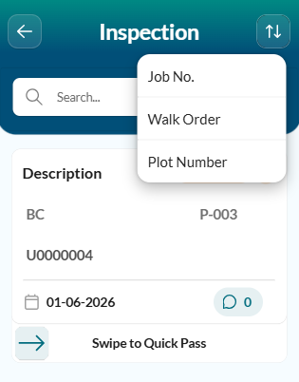
Sort Options

Swipe Action / Contextual Swipe (Quick Pass)
Swipe action or contextual swipe button is used when user wants to quickly pass an inspection without filling in all the details. This action button is only available in the records of the Inspections Menu.
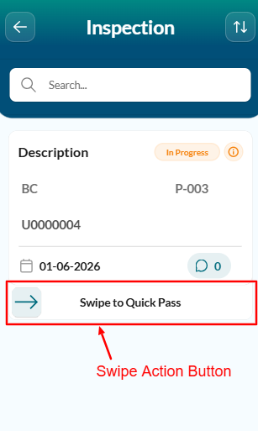
Swipe Action Button

Toast Message
A Toast message of shown when there is no task to display
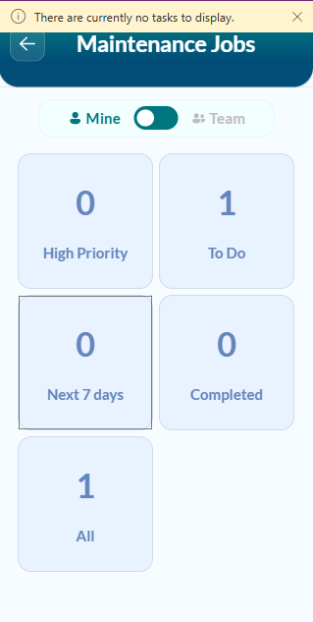
Toast Message

Time Log / Time Entries
Time Log is available for three menus –
- Maintenance Job
- Housekeeping
- Services
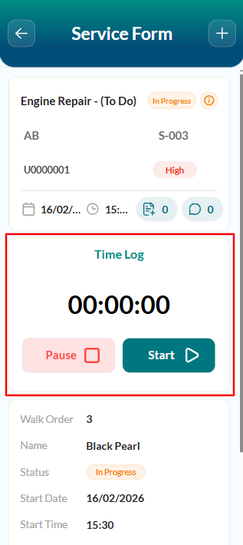
Time Log

Task Lists
Task List is sub part of Tasks. These Induvial tasks make up to a particular task (Ex. Any housekeeping task)
Task Lists are available for three Menus –
- Housekeeping
- Service
- Inspection
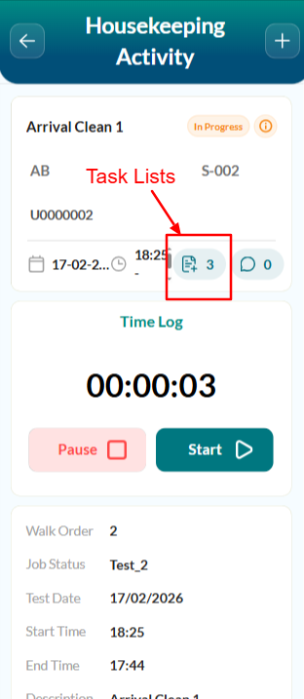
Task List Button
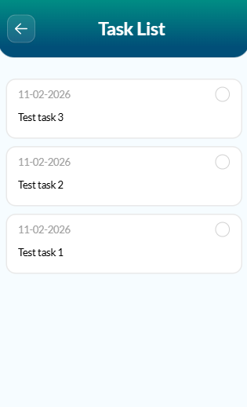
Task List

Complete / Update Button
Complete button – Sets the task status as completed.
Note: To set the task status as complete, the user must first check all the task list if applicable for that task.
Update button – Changes the task status
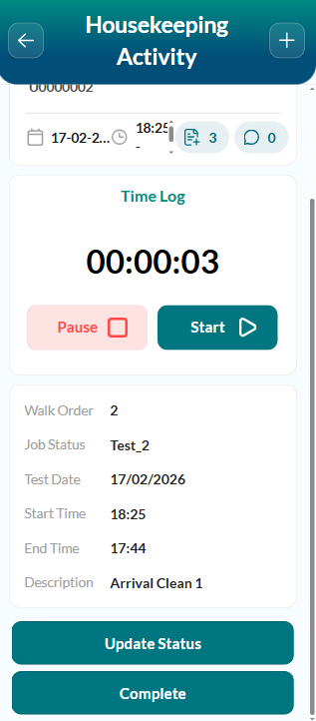
Update / Complete Button

Permission to Enter
Permission to Enter is just a display field which is managed from the CRM side.

Requests
Requests can be managed from two ways –
- From Home Page: It shows all requests (of every menu) by the user
- From Detailed Page of a particular task: It shows all the requests (including the end user/team) regarding that task/record
Requests can only be created. No edit or Delete option available.
Users can attach a photo to a request.

Comment
Comments can only be created. No edit or Delete option available

Mooring Status
Mooring status field is associated with Inspection Menu. Its status has two options – In or Out

CRM Overview
“Elite Site Operations” is the CRM (Model-driven app) which is used to manage Menus, Tasks, User Permissions and viewing the stored data.
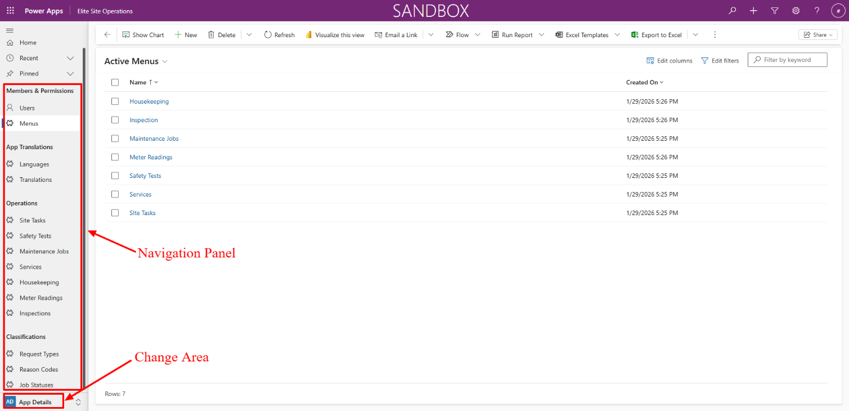
CRM Home Page
Navigation Panel has Different table details, while the Change Area is used to navigate between “App details" and "More Info”.
Table | Use
Users | Manages access and permissions to users
Menus | Manages active/inactive menu access and permission to users
Languages | Shows active/inactive languages
Translations | Have translations of different languages
Site Tasks | Records regarding site tasks
Safety Tests | Records regarding safety tasks
Maintenance Jobs | Records regarding maintenance jobs
Services | Records regarding services
Housekeeping | Records regarding housekeeping
Meter Readings | Records regarding meter readings
Inspections | Records regarding inspections
Request Types | Shows and manages active/inactive Request Types
Request Quotes | Shows and manages active/inactive Request Quotes
Job Statuses | Shows and manages active/inactive Job Statuses

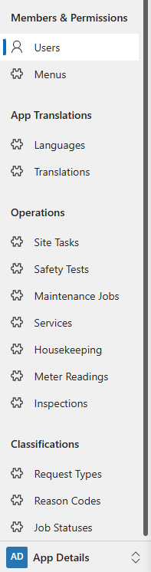
Navigation Bar – App Details
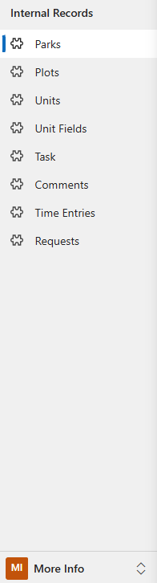
Navigation Bar - More Info
Table | Use
Parks | Contains Park code from Business central
Plots | Contains Plot code from Business central
Units | Contains Units No from Business central
Unit Fields | Contains Unit fields from Business central
Task | Records regarding tasks
Comments | Records regarding comments
Time Entries | Records regarding time logs
Requests | Records regarding requests

Important Calculations/Equations
- All: Include all the records of tasks whose task status is not “completed”
- Completed: Include all the records of tasks whose task status is “completed”
- To Do: Includes all the records of tasks whose task status is not "completed” and it’s “Due Date” is on or before 11:59:59 pm of the current date
- Next 7 days: Include all the records of tasks whose task status is not “completed” and it’s “Due Date” is with in the next 7 calendar days
- Team: All the tasks within the user’s team which he/she has permission to

Glossary
Term | Definition
RBAC | Role based Access Control
DEV | Development
Env | Environment
UAT | User Acceptance Testing
PRD | Production
Cards | Referred to clickable square/rectangle displaying data
CRM | Referred to “Elite Site Operations” the Model Driven App
Days | Days refer to calendar days
Current Date | Refers to 11:59:59 pm of today’s(current) day

